Information Systems Division

MDM Test Strategy
Project ID: MDM
Project Name: Profit Program
Revision Number: V5.0
Project Manager Name: Tarun Dasari
Document Author Name: MohanaRao Gutta
Table of Contents
1. Purpose 1
2. Objectives 1
3. Scope 2
3.1 Types of Testing 8
4. Test Approach 10
4.1 Country Deployment Test Plans 13
4.2 Test Environment Strategy 14
4.3 Test Cases Strategy 14
Use Cases 15
Business Scenarios 16
Test Cases 16
4.4 Test Data Strategy 17
4.5 Test Tools Strategy 17
4.6 Test Automation Strategy 17
5. Roles and Responsibilities 19
6. Control Procedures 21
6.1 Defect Management 21
6.2 Defect Triage Team 22
6.3 Defect Closure 23
6.4 Test Metrics 23
6.5 Change Management 23
7. Test Deliverables 23
8. Revision History 24
9. Appendix 26
9.1 Defect Severity Definitions 26
9.2 Test Case Completeness Checklist 27

Purpose
This Master Test Strategy outlines the strategy and the approach that are to be used to plan and execute testing activities for all Master Data Management (MDM) country deployments within the Profit Program. It represents the policy and guidance in developing the Test Plan for each country deployment. It is for the use of the Project team in understanding and carrying out prescribed test activities and in managing these activities through successful completion. The MDM Program will enforce adherence to the policies set forth in this document.

Approvals
This document requires the following approvals:
Name/Signature | Title | Date
Tammy Skahan | Wal-Mart Profit Program Manager
Joanne Byrd | Wal-Mart MDM Functional Program Manager
Tarun Dasari | Wal-Mart MDM Technical Program Manager
Gilbert Wiatrek | Wal-Mart Location Functional Owner
Toby Coyle | Wal-Mart Supplier Functional Owner
George Pappanastos | Deloitte Profit Program Integration Manager
Gary Burton | Deloitte Profit Program Test Manager
Michael Godette | Deloitte MDM Technical Program Manager
Todd Judkins | Deloitte MDM Functional Program Manager
Lane Warshaw | Deloitte Supplier Lead
Tarun Goel | Deloitte Location Lead

Objectives

This Master Test Strategy has been developed to fulfill the following objectives:
- To define the management and technical effort necessary to support MDM testing throughout the system development life cycle.
- To establish a comprehensive Test strategy that identifies the nature and extent of tests deemed necessary to achieve the testing objectives for the MDM Program.
- To coordinate an orderly schedule of events, identify organizational requirements, describe test methodologies and strategies to be used, and identify items to be delivered.
- To provide a plan for designing, documenting and executing detailed use cases, test procedures, cases and scripts.
- To help standardize the test effort and make it more efficient.
- To serve as a common document of understanding for all parties identified for supporting the testing activities to be performed.

This strategy will set policy, solution design quality expectations, roles, and responsibilities for those functions in the MDM to conduct the business of test. This strategy will outline the structured software testing processes and policies at the MDM Program Level that supports with the Profit Program Test Strategy.

Scope

The MDM program is a part of the Profit Project which is aimed to achieve a Finance Vision that includes 5 initiatives:
- Redesign financial master data to enable consistent data definitions, structure and governance;
- Implement new core financial systems to enable use of robust controls embedded in systems, foundational data traceability, and an efficient financial close process;
- Implement new information architecture to enable “one version of the truth,” improved analysis and decision-making and flexible self-service;
- Implement financial planning system to enable improved bottom-up, top-down planning and forecasting; and
- Improve inventory integration to enable a consistent view of inventory, cost and margin for better decision-making to drive margins and improve inventory performance.

MDM is creating the trusted source for Location and Supplier. It will eliminate duplicity of data across multiple IT systems. It will also address challenges with keeping data in sync resulting in reductions of errors due to incorrect data that can impact the business. Being that Wal-Mart is the largest retailer in the world, the change to the management of its corporate master data is expected to enable Wal-Mart meet its growing and ever-changing global business needs.

Countries in scope of deployment of MDM are:
- UK
- Argentina
- Mexico
- Japan
- US/Puerto Rico
- China
- India
- Central America
- Canada
- Brazil

The primary scope of testing that will be performed for MDM are aimed to verify that:
- The functional, and non-functional, requirements are met to ensure the integrity of the location and supplier master data.
- Error handling is implemented as specified within the requirements and designs.
- The data and supporting UI applications are acceptable for use by the Business.
- All of the components are in place and ready to be moved to production.

As a result of testing, it is expected that the following will be likewise achieved:
- Instill confidence in the system, through user involvement.
- Ensure that the interfaces between all external systems requiring location and supplier master data work.
- Identify problem areas where the system deliverables do not meet the agreed to specifications.

By the nature of the project, there will be 2 major groupings of validation to be executed:
- Data Transformation and Integrity Validation – This will ensure all the required data has been extracted and transformed based on predefined data requirements and associated business rules. Validation will be defined at various control points in the process to ensure early detection or introduction of defects. This validation will encompass extract from legacy thru availability of data for consumption by legacy systems, SAP and BI applications.
- UI validation – This will ensure User interfaces meet the functional requirements that will support the currency, accuracy and completeness of Location and Supplier master data. This will include the backfeeds to Legacy as required.

Test execution will be ‘Agile-like’ as it will be highly dependent on the Development team’s schedule of multiple code drops for new functionalities as well as code fixes. To validate data, some level of integration process runs are required to make data available at different state of transformation. Within each iteration there will generally be 3 cycles of testing intended to do first-pass testing, testing of fixes and regression.

The diagram below depicts the various components of MDM Location Integration process:

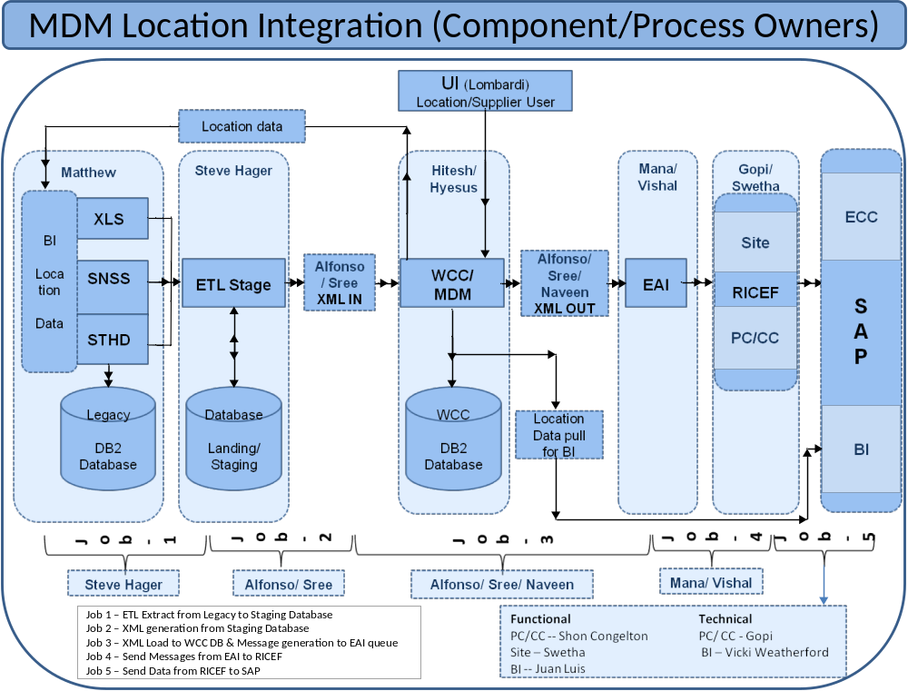

The diagram below depicts the various components of MDM Supplier Integration process:

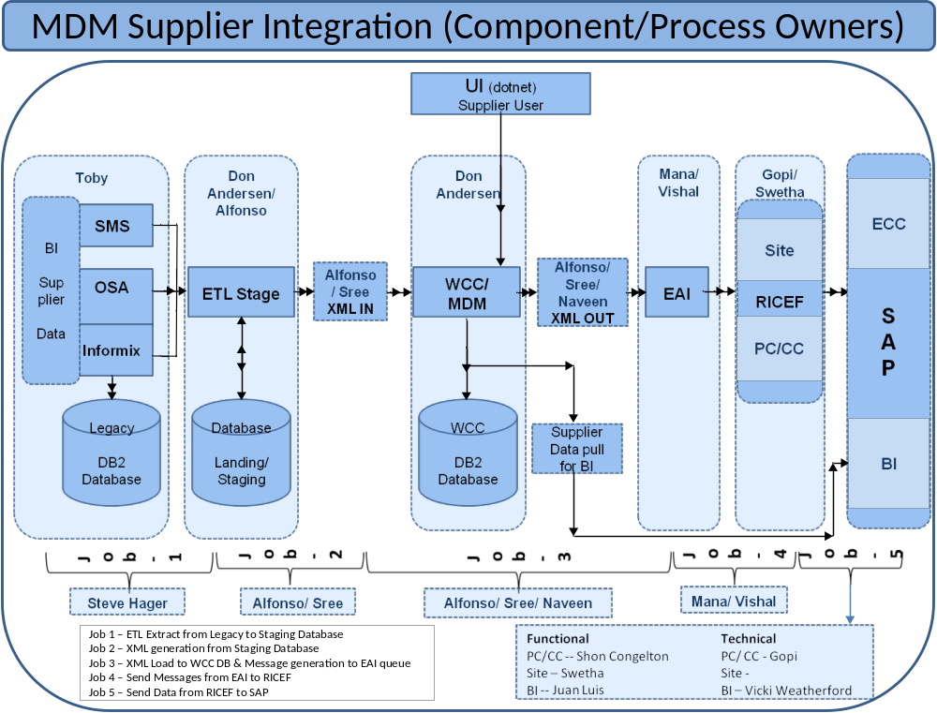

Below are the High Level Business Processes that are to be supported and will be tested. Please note this list is from a Global perspective; the detailed country deployment test plans should specify any deviations from this list or any country-specific processes. Detailed test plans will be created as part of the deployment effort and are considered part of this Master Test Strategy.

Location:

High level Business Processes that are to be supported and will be in scope for testing
Initial Load to support the following location types:
- Global New Retail /Wholesale Locations
- Global Retail/Wholesale Expansion
- Global Retail/Wholesale Remodel
- Global Retail/Wholesale Takeover
- Global New Distribution Center
- Global Home Office Setup
- Global Cost Center Setup
- Global Legal Entity Setup
- Complete location setup to support multiple hierarchies and perspectives(e.g. geography, reporting responsibility, legal entity and tax jurisdictions
Initial load that will include:
- Extract of location related data from current Systems of Record;
- Transformation of data by applying Data Quality and Integrity checks to cleanse the data; and
- Load of organized and cleansed data into MDM.
User Interface that will include:
- Entry of location information;
- Validation of user input applying similar Data Quality and Integrity checks as initial load; and
- Load of data into MDM.
External system interfaces to allow retrieval and load of data from MDM to other consuming systems.

Supplier:

High level Business Processes that are to be supported and will be in scope for testing
Initial Load to include:
- Loading of customers that are not suppliers that currently do not exist in any system;
- Loading into MDM of all suppliers and their associated records with ACTIVE or INACTIVE status. Suppliers with DELETED status will not be loaded;
- The use of of a third party service such as Dun and Bradstreet to generate the supplier family relationships; and
- Data cleansing and standardization of fields such as addresses and supplier classifications.
Delta Load applying similar Data Quality and Integrity checks as initial load
Use of one Global Supplier Number(GSN) for all countries
Retention of historical changes to supplier information
User Interface that will include:
- Entry of supplier information;
- Validation of user input applying similar Data Quality and Integrity checks as initial load; and
- Load of data into MDM
External system interfaces to allow retrieval and load of data from MDM to other consuming systems.

Types of Testing
The following table contains information about the types of test that are in scope for this project:

Type of Test | Purpose | Owner
Technical Unit Test | - Tests components, modules or programs with regards to internal logic, path and condition coverage, exception conditions and error-handling and proper interfacing between modules to meet technical specifications | Development teams
Functional Unit Test | - Confirms the system supports the business processes  - .Verifies interfaces are created according to the design  - Validates configuration of each individual transaction code | Functional Business and MDM Test Teams  (Cognizant team)
MDM E2E Integration Test | - Tests end to end business scenarios  - Validates integration of all system components  - Verifies accuracy of data conversion  - Identifies and resolves problems related to the use of combinations of systems, products and/or solutions that were developed separately but are being used together. There can be three levels of software integration tests:  - Platform integration test - ensuring key products interoperate with the product under test  - Product integration test - ensuring all software products on a platform interoperate  - End-To-End Tests - ensure components interact to deliver the correct business functionality | MDM Work stream Owners/Function Business and MDM test Teams
Regression Test | - Tests changed modules has not compromised existing functions and can work with unchanged modules  - To verify the defect fix has not affect any existing functionality. | Functional Business and MDM Test Teams  (Cognizant Testing Team)
User Acceptance Test | - Verifies that the testing being performed meets the requirements of the end users  - Provides assurance to stakeholders that the end user can satisfactorily use the system to conduct business following an expected process flow  - Verifies that the deliverable is working as requested by the business owner and is free from behavior that prohibits the real user from doing their job | Executed by Functional Business Teams  Led by Business Leads

Test Approach

The Overall test strategy is driven by finding the most number of defects as early as possible at the lowest cost. Testing proceeds through various levels of testing in the application development lifecycle. Each completed level represents a milestone on the project plan and each stage represents a known level of physical integration and quality.
The MDM Test Planning and Execution Approach and associated key activities are illustrated below. Quality gates in the form of formal reviews and signoffs are embedded into the process to ensure that concurrence is obtained from the appropriate stakeholders prior to proceeding to the next step.

MDM Test Planning and Execution Approach
Test Status Tracking and Reporting
Test Execution
Test Environment Setup
Test Development
Test Preparation and Planning
Business Objectives and Scope
Business and Technical requirements/ specifications are defined, documented, prioritized and signed off
Business scenarios (Use cases) are defined, documented, prioritized and signed off
Solution design completed
Test Strategy and Plan documented and signed off
Traceability of Use cases to solution design to technical and business requirement are established.
Test scenarios/ test cases are defined, documented, prioritized and signed off
Traceability of test cases to use cases are established
Test cases are loaded in HP QC
Test cycles and schedule are determined
Review of test coverage is conducted and signed off by Functional Stakeholders
Test environment and data requirements are defined and documented
Test environment plan is documented and signed off
Test data plan is documented and signed off
Environment/infrastructure is installed; available for test execution
Test data is ready
Test Team is prepared to begin test execution
Test readiness review is conducted and signoff from stakeholders to proceed with testing is secured
Testing kick off meeting is conducted
Test cases are executed
Results of testing are logged
Defects are logged
Defects are resolved
Test execution status is tracked and reported
Defect status is tracked and reported
Completion of test against exit criteria is reviewed with Stakeholders

Integration Test Lead, Testers, Functional SMEs and Tech Leads/developers

Test Manager/Defect Manager
Application Architect/Lead,
Functional Leads and Test Team
Functional SMEs and
Test Team
Functional SMEs and Test Team

The following best practices will be implemented to ensure quality of testing:
- Reuse existing test assets and use of a common set of templates to document test planning and test result activities.
- Enforce traceability of test cases to Requirements, Use Cases, and Business Scenarios. This traceability plays an important role to verify that an implementation fulfills all requirements, verify that the application does what was requested and it will help with change management to identify impacted test cases from implemented changes.
- Evaluate all test cases created for gaps in coverage and redundancies. This effort is in collaboration with Business SMEs , developers and tester.
- Identify Business SMEs and development contacts to resolve any requirement questions and business processes.
- Improve the quality of test data by having the Business SMEs involved in the data validation review prior to test execution start.
- Adhere to the following priority sequence is followed when executing test cases:
  - Defect fix verification
  - Regression test function or adjacent function that should not have been affected by the planned changes/additions to the code drops.
  - Test cases that were blocked from execution and can now proceed to execute as a result of the defect being fixed
  - New Test cases that have not yet been executed.
The objective for following the above test case execution sequence is to allow rapid feedback to the developer on changes/additions made to the code. Since the developer may be developing on previously made code changes, immediate feedback on the introduction of defects saves development time and rework.
- Improve the effectiveness of defect fix verification by performing a detailed analysis of the fix and identify potential areas of code impact.
- Use of automated testing tools for specific testing.

In every level of testing, considerations will made be made to incorporate the following:
- Positive Testing - Testing the normal functional path.
- Negative Testing - Testing that exceptions are properly handled by the component.
- Disruptive Testing - Testing that the component/system can recover from unexpected failures or undesired conditions.
- Regression Testing – Testing to validate unchanged functionality still works. This will also apply to applications having common components being changed. In every country deployment, some level of regression testing will also occur for counties already deployed. To verify the defect fix has not affect any existing functionality.
Entry and Exit Criteria
The concept of establishing pre-requisites (entry criteria) and post conditions (exit criteria) is extremely important in managing any process. The need for using entry / exit criteria is documented to ensure clear understanding where hand offs occur so that the sending organization or unit can verify completeness before handing over and the receiving unit can validate ‘readiness’ to initiate the process.
Entrance criteria are those factors that must be present, at a minimum, to be able to start an activity. If the entrance criteria of the next phase have been met, the next phase may be started even though the current phase is still under way.
Exit criteria are those factors that must be present to declare an activity completed. For MDM, below are the prescribed Entry and Exit Criteria.
Entry Criteria
- Administration
  - All test roles and responsibilities are documented in the Master Test Plan.
  - Test Ids are created and verified.
- Test Environments
  - Test infrastructure is installed and ready for test.
  - Required test data is loaded and visible
- Test Plans
  - Plans for each test type are completed, reviewed and approved by stakeholders before start of test phase.
  - All Test Cases for each test type have been written, reviewed and approved by stakeholders before start of testing.
- Deviation from Entry Criteria
  - Any deviation to the entry criteria will require the approval of stakeholders.
Exit Criteria
- All test cases executed to a pass/fail status.
- Results are completely documented and communicated to the project team.
- All Showstopper, critical and high severity defects* have been resolved.
- Any unresolved medium and low severity defects* have an agreed to plan of resolution.
- All test cases for a test phase have a 95% pass ratio.
- Stakeholders concur on application stability.
- Stakeholders agree on any deviation from the criteria.

(*Note: Please refer to Appendix 9.1 for Defect Severity Definitions)

Country Deployment Test Plans
At a minimum, every country to be deployed must document the following for each Test Type to be executed:
Country:
Test Type:
Country Leads:
Objective
Entry Criteria |  | Exit Criteria
Planned Coverage
Test Execution Approach
Test Data Approach
Test artifacts repository | Functional Specifications:  Technical Specifications:  Business Scenarios:  Test cases:
Resources
Milestones
  Tasks | Start Date | End Date
  - Test Preparation and Planning
  - Test Development
  - Test Execution
Level of Automation
Environments
Dependencies
Assumptions/Constraints
Other test information

A test plan entry based on the above information will be created in Quality Center.

Test Environment Strategy
The attached document specifies the details of the test environment used for the entire project testing. 

Test Cases Strategy

The testing process that is being followed is part of a methodology that begins with defining the functional requirements as documented in the Functional Specifications. Part of defining the functional requirements includes developing Use Cases, which detail how people interact with the system.

Once the Use Cases have been developed, the requirements are reviewed and a set of business scenarios should be written. A business scenario defines, at a high-level, how a given business or technical requirement will be used, including the expected outcome.

The Test Scenarios will then split into Test Cases, which are granular repeatable tests that validate a specific component or function of the solution.

Use Cases
The main purpose of use cases is to establish the boundary of the software system and fully state its functional capabilities with respect to the users. The use cases also:
Provides a basis for communication between end-users and system developers
Is the primary driver for estimating the application development effort
Provides a basis for planning the development of the solution
Provides a basis for identifying objects, object functionality, interaction, and interfaces
Provides the primary basis for defining the user interface requirements
Provides a basis for defining test scenarios
Provides a basis for producing user support materials and documentation

Use cases should describe textually. The concept of an actor is introduced – this is someone who interacts with the system typically a user or a system administrator.

Following are some characteristics of use cases, which:
- Are initiated by an actor
- Model an interaction between an actor and the system
- Describe a sequence of actions
- Capture functional requirements
- Should provide some value to an actor
- Represent a complete and meaningful flow of events

Use Case definitions must include the following information:
- The event that triggers the use case.
- A brief description of the use case
- The actor initiating the use case as well as secondary actors
- Preconditions – constraints that must be met for the use case to be executed
- Terminating Outcome – the alternative ways that the use case may terminate, including the conditions affecting the terminating outcome
- A description of the events of the most likely to occur and the termination outcome – i.e. what the actor does and how the system responds

To ensure completeness, traceability to business requirements is recommended.

Here is the sample Wal-mart SDLC Business case template which can be used

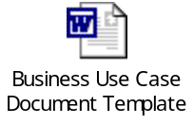

Business Scenarios
Business scenarios will be derived from the functional requirements as specified by use cases and the non-functional requirements, such as peak load handling, response time expectations, and access control needs. They will be used to evaluate the testability of requirements, and to identify any ambiguous, incomplete or missing requirements.

A Business scenario will define at a high-level, how a given business or technical requirement will be tested, including the expected outcome. A business scenario will reflect an end-to-end transaction and require the execution of multiple test cases to demonstrate its full functionality. The Business scenario description may include references to those test cases.

To ensure completeness, traceability to Use Cases is recommended.

Business Scenario Spreadsheet to use:
- Team Excel documents are stored on the eRoom in folder:
> 02.0 UK Team > 02.8 Integration Management > 02.8.01 Integration Testing > 02.8.01.01 Test Case Development > 02.8.01.01.00 Key Business Scenarios
- File: Key Business Scenarios All Teams_v3.xls -All Teams will share the spreadsheet which is checked out for edited and version tracked

Test Cases
Test Cases are the most granular unit of testing. They will be derived by reviewing the Use Cases and Business Scenarios and dividing them into component tasks. Test Cases will detail each step that must be performed along with the expected results. The definition should also include the set-up and environment considerations, test data, and pre-requisites for each test case.

To ensure completeness, traceability to Business Scenarios is recommended.
Test Case Template to use:
- Excel document stored on the eRoom in folder:
> 00.0 Global TMO > 00.4 PROFIT Templates > 00.4.07 PROFIT Testing Templates
(Example & Template Instructions in same folder)
- At lease one test case will be created for each business scenario
Appendix 9.2 is a Test Case Completeness Checklist that can be used to verify completeness of details proved for each documented test case.

Test Data Strategy
TBD - Specifies the details of the test data used for the project testing.
It is primarily driven by the Business Team.

Test Tools Strategy
Rational ClearCase will be used for software configuration management to ensure proper version control supporting parallel development (ex: new releases and production changes).
HP Quality Center Testing Tool (a.k.a. Quality Center) will be the application to manage and track test execution as well as defect reporting and management. Functions to be supported will include:
  - Repository for Test Cases;
  - Tracking of test case execution activities;
  - Defect recording and management
  - Reporting and metrics of test case execution and defects

HP Quick TestPro (QTP) will be used as an Automation tool.

Test Automation Strategy
.

<This whole section has to be re-written as per the new test automation strategy from Cognizant. The below update has been put as a skeleton. But has to be updated>

The MDM program currently performs data migration from Legacy to SAP. The verification of the migrated data is performed manually to ensure accuracy of the migration. Automated scripts can significantly reduce the verification process time and increase its accuracy.

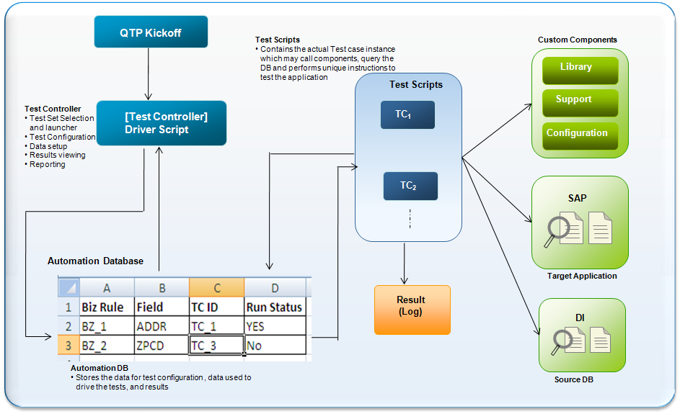

Benefits
- Reusability of utility scripts, reports package
- Scripts are easy to maintain, debug, and modify because of modularity
- Significant reduction in time for testing large volume of data
- Provision for execution of scripts in multiple environments
- Easier, faster, and efficient analysis of result logs
- 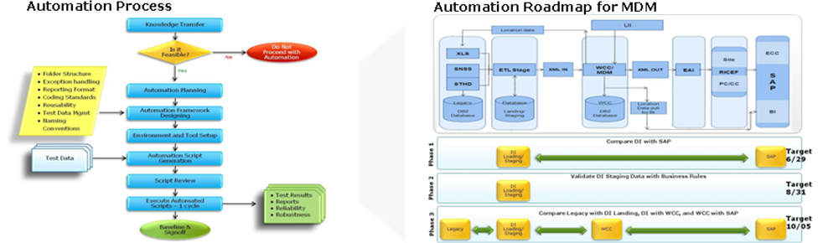
A PoC for automation of the verification process for periodic data transfer of Supplier delta load from Legacy to SAP on UK environment has just been completed. The future automation phases will include verification of data transfers between individual systems and verification of business rules.
Phase 1
- Automate the comparison of DI data to SAP screen outputs
- Document the automation approach using the Object Oriented Framework
Phase 2
- Identify pass through and transformational test cases
- Create mapping of Biz rules to data transformation test cases
- Automate testing of Biz rules for DI staging (Delta loads)
- Identify/create process to simulate data change conditions from the legacy systems
Phase 3
- End to End testing of data flow from Legacy to DI to WCC to SAP
- Reuse existing components and develop new components to address data flow transformations from source (legacy) to destination (WCC and SAP)

Roles and Responsibilities

Testing Functions | Responsible Role | Responsible Person or Group
Test data management | Wal-Mart Infrastructure Lead | Hitesh Muni
Test script development | MDM test team | MDM test team member
Test planning | MDM Test Manager | Mohan (Location)  Madhu (Supplier)
Test coordination or management | MDM Test Manager and Integration Test Lead | Mohan (Location)  Madhu (Supplier)
Test case creation | Functional Business and MDM test teams | Functional Business and MDM test team member
Test tool support | Wal-Mart Infrastructure Lead | Hitesh Muni
Test execution | Functional Business and MDM test teams | Functional Business and MDM test team member
Auditing | Wal-Mart Infrastructure Lead | Hitesh Muni
Defect Management | MDM defect Manager | Rebecca Keegan
Test environment setup and management | Wal-Mart Infrastructure Lead | Hitesh Muni
Test status reporting | Test Manager and Integration Test Lead | Mohan (Location)  Madhu (Supplier)

Control Procedures

Defect Management
Profit Program Defect Management Process will be implemented for MDM.
- Defects are logged using HP Quality Center for all test phases
- Defect management allows the recording of all relevant information required to resolve a defect
- Defects can be created within the testing process and live within HP Quality Center
- The user can add a detailed description of the failure along with screen shots and attachments in HP Quality Center
- Defect management begins with the unit test cycle; any test related problems are fixed and promoted through the landscape via the defect number
- The Defect Manager is required to act as the gatekeeper of the process. Duties include:
- Monitor testing execution
- Facilitate daily defect review meeting
- Approve the close of defects (requires evidence of testing documentation and verbal approval from functional owner) – this information will then be entered and the defect updated/closed in HP Quality Center
- Handoff to transport management group for promotion of corrections
- Produce detailed defect reporting on a daily basis and communicating status
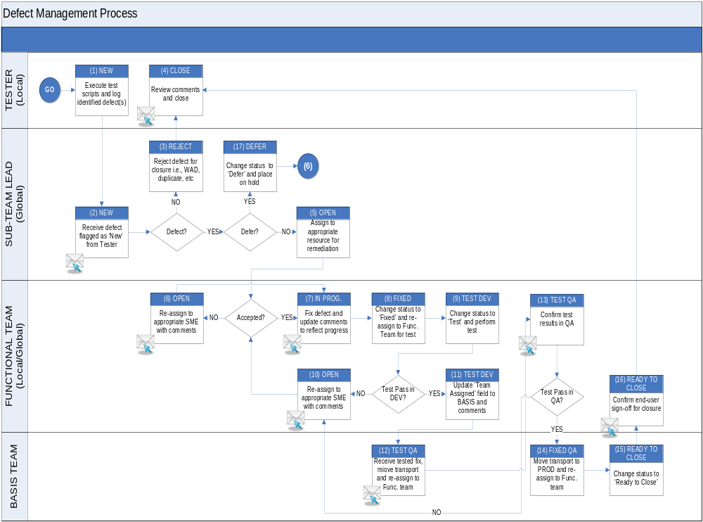

Defect Triage Team
Defects should be reviewed constantly by a review board. The board may consist of various persons like Project Manager, Business Analysts, Tester and Developer. The purpose of the board is to decide certain action on the defects that are originated.
Defect Meeting and Process
Defects are reviewed by the defect triage team during the daily defect meeting. All defects should be reviewed and updated prior to the meeting.
During the defect meeting, it is the team’s responsibility to validate and verify the defect fix, the appropriate severity level, and determine the next course of action. The person that has the defect assignment is expected to provide an estimated close date during the meeting or after the initial research and investigation into the underlying cause. Once the underlying cause is determined, development can proceed with providing a more realistic and accurate estimated close date.

Defect Closure
Defects can only be closed by the person that detected the defect. Once the defect is fixed, the defect is reassigned to the person that detected the defect. The defect is then verified for completeness and accuracy. If verified as fixed, the tester updates the defect with comments and the defect is changed to a status of closed. If the defect is not fixed, the status is reopened. The reopened defect is assigned back to the appropriate developer for resolution.

Test Metrics
Metrics used for reporting will include data on test case creation, test execution results, defects and change requests in HP Quality Center.
- Test Results Metrics
  - Number of test cases planned per test phase
  - Number of test cases executed per test phase
  - Pass ratio (passed test cases to total executed test cases)
  - Failed ratio (failed test cases to total executed test cases)

- Defect Metrics
  - Total number of defects found
  - Ratio of open defects to total defects
  - Total defects rejected or deferred
  - Defect aging
  - Defects per test phase
  - Defects by status (i.e. open, closed)
  - Open defects by severity (i.e. 1 – Showstopper, 2 – Critical)
  - Outstanding defects* over time (cumulative totals)

*Outstanding defects consist of those NOT in a status of “closed”, “deferred”

Change Management
The ISD and Customer project sponsors must approve any proposed changes requested prior to any application being made. All changes have to go through the ISD change management process. Attach any approved change controls that impact the Test Strategy.

Test Deliverables
The following table contains the list of deliverables for different types of testing:

Deliverables | Responsible Group | Approvers
Test Plan | MDM Test Manager | MDM Stakeholders  Profit Leadership Team
Defect Reports | Defect Manager and Coordinator | Not applicable
Automated Test Scripts | MDM Test team | Not applicable
Functional Unit Test Cases | Functional Business and MDM Test Teams | MDM Stakeholders  Country Stakeholders
Integration Test Cases | Functional Business and MDM Test Teams | MDM Stakeholders  Country Stakeholders
User Acceptance Test Cases | Functional Business Test Teams | MDM Stakeholders  Country Stakeholders
Performance Test Cases | Functional Business and MDM Test Teams | MDM Stakeholders  Country Stakeholders
Regression Test Cases | Functional Business and MDM Test Teams | MDM Stakeholders  Country Stakeholders
Test Status Reports | MDM Defect Manager | Not applicable
Test Schedule | MDM Test Manager | MDM Stakeholders  Country Stakeholders
Test Summary Report | MDM Test Manager | Not applicable

Revision History
The following table contains the revision history of this document.

Revision Number | Revision Date | Author and Title | Description
V1.0 | 10/30/08 | Cynthia Chow/MDM Test Manager | Initial creation of MDM Master Test Strategy
V2.0 | 01/07/08 | Karen Greene/Defect Manager | Updated the defect triage section
V3.0 | 01/07/08 | Cynthia Chow/MDM Test Manager | Updated Process loads
V4.0 | 01/07/08 | Cynthia Chow/MDM Test Manager | Merged V2 and V3
V5.0 | 07/23/09 | Sudhakar Kandanala / MDM Test Manager | Updated as per the current process.
V6.0 | 08/02/10 | Mohan  Test Lead | Updated for MX

Appendix

Defect Severity Definitions

Show Stopper - target turnaround time 24 Hours

- An error that prevents the accomplishment of functionality of a high-priority process as identified in the requirements.
- A high-priority process is missing or does not work.
- An error that abnormally stops program execution. Also, an error that prevents the program from compiling, being interpreted or from loading.
- An error that jeopardizes personnel safety, data security or data integrity (any loss of data situation).

Critical - target turnaround time 72 hours

- Impact areas critical to the business
- Might stop the current test execution
- Testing is possible but meaningless unless the defect is fixed
- An error that adversely affects the accomplishment of functionality of a high priority process. The error degrades performance and no work-around solutions exists. This is functionality that works, but is not quite right or not for all data cases.

High - target turnaround time 7 days

- Serious and confined to a functional area
- Workaround is possible
- A low-priority that des not work
- A performance error
- An error in data compilation. Missing or incomplete records returned during a query.
- A hypertext link that does not point to the correct page, but the correct page can be reached from another link.
- A complex screen that is difficult for the user to operate or navigate that causes a high probability for user error.

Medium - target turnaround time next build if feasible or sooner thereafter if possible. Should resolve as many as possible before go-live

- An error that is an inconvenience to the user and does not affect the functionality of the program. This includes errors that could be eliminated by training users.
- Missing non-essential fields
- A low-priority process that works but not quite as it should
- Operating system and off-the-shelf software generated errors that are outside program control to correct

Low - target turnaround time as time and resource allocation permits

- Cosmetic with little or no impact to user
- No rush to resolve
- Formatting issue
- Alignment in a dialog box and/or on a report
- All other errors
- Functionality that is beyond scope of the project

Test Case Completeness Checklist

Test Case Overview
- Can the boundaries or scope of the test be clearly identified?
- Are all prerequisites and other related documents identified?
- Is the test traceable to requirement(s)?
- Are the associated Detail Testing document(s) identified?

Approach
- Does the document describe how the test is to be conducted?
- Are all resources and conditions required for completing the test identified?
- Have the expected results of the test been identified?

General
- Are the test instructions clear and easy to follow?
- Is the test as described likely to test what it intends to?
- Do the expected results reflect your expectation of the test result?
- Does every test case include a description of the expected output or results?
- Are the test cases sufficiently documented so as to be 100 % reproducible?
- Do test cases include verification of proper return codes?

